Brand Essence

Vision: To become the world's most loved heritage lifestyle brand, where every product carries the soul of Indian craftsmanship and the spirit of global living.
Mission: Premium timeless companions for life's meaningful moments
(To honour Indian craft heritage by creating timeless companions for conscious living - one material, one artisan, one story at a time.)
Tagline: "Made for Living" or “Luxury is Handmade”
Brand Philosophy:
A brand not based on products but for people and their interests. A brand that grows from experiences and a love for the art of living. A brand that cherishes stories and brings people together to share laughs, moments, and memories. Building around hobbies, shared interests, and new experiences. We create for you to cherish life and embrace it from within.

“Celebrating the art of living through craft that tells your story.”

How the Journey Started
(About the product line)

2015: Launched Parks India - a mother-daughter duo
2016: Went from a kiosk to a flagship store setup

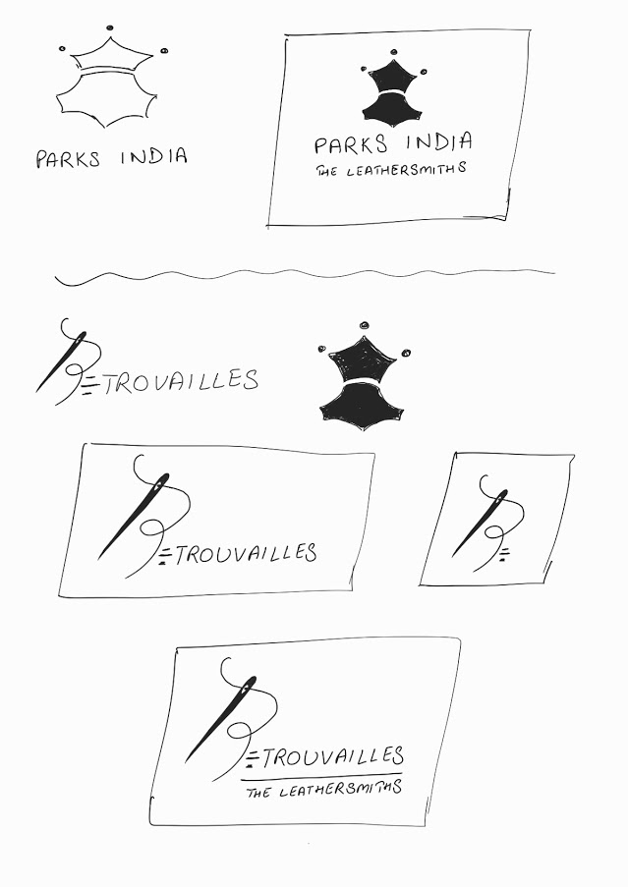

2025: Rebranding as ‘Tan Lerida’

Our Logo
Initial
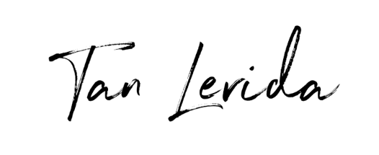
Final
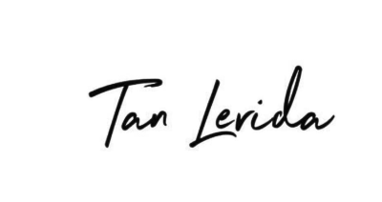

WIP Stuff: (a couple of things I tried, lol)

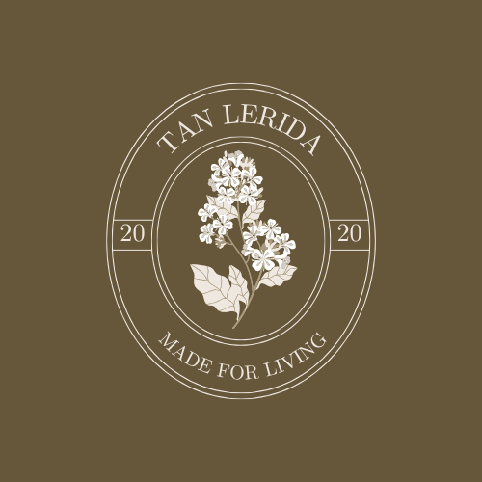
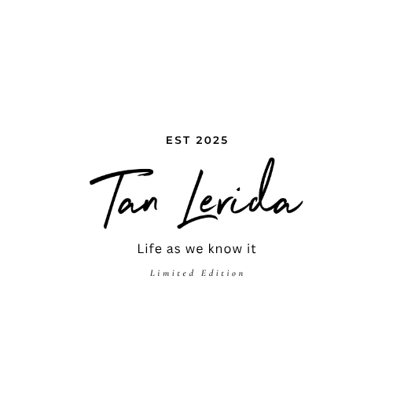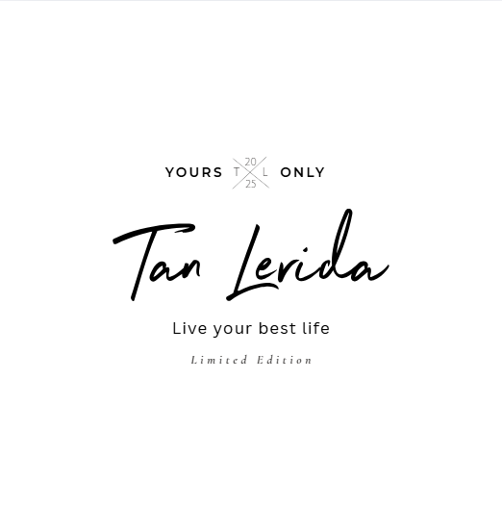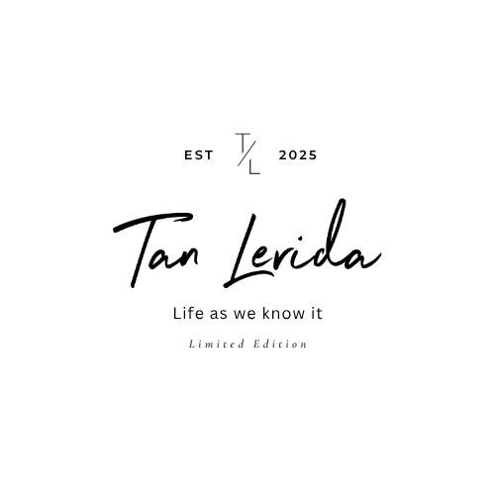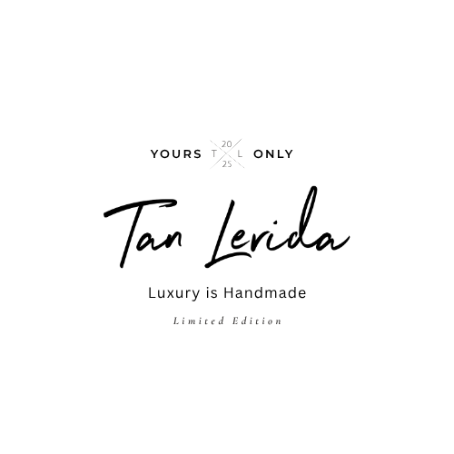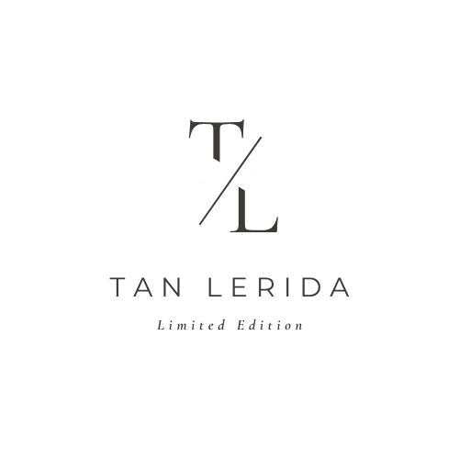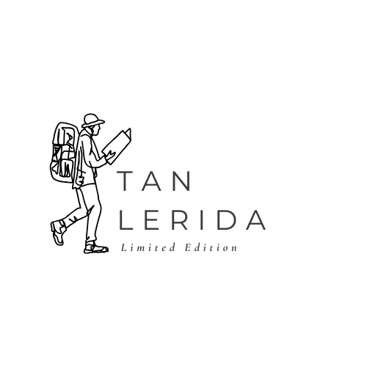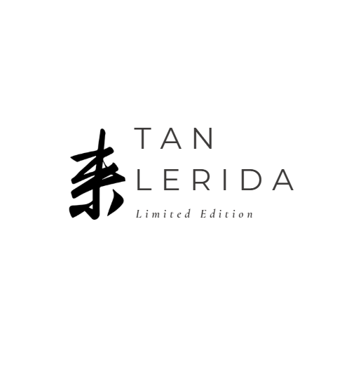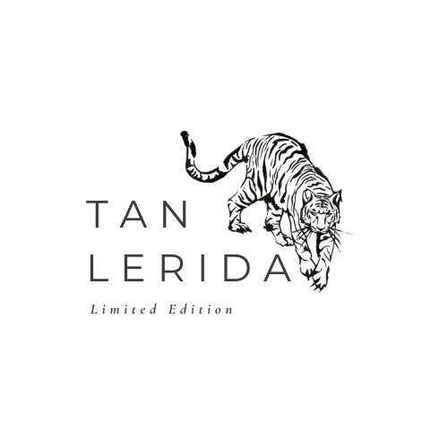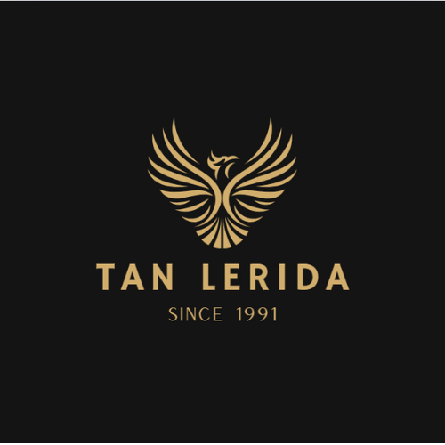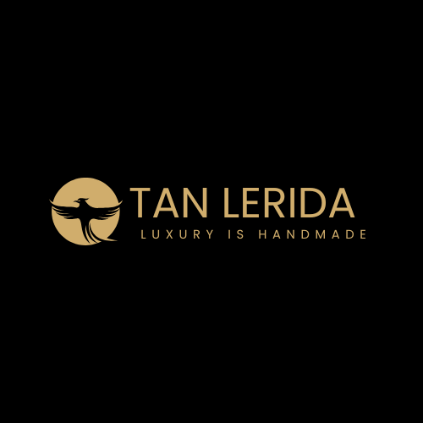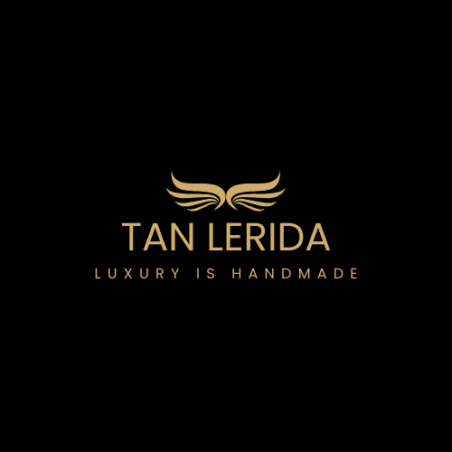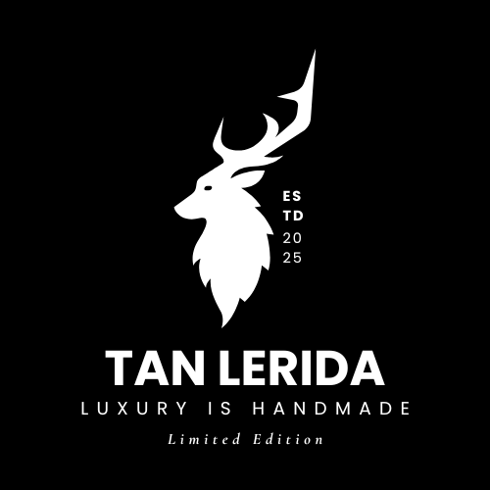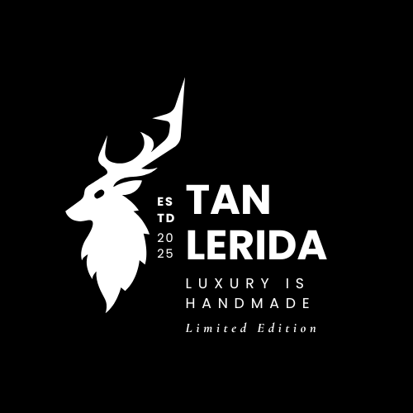

Symbol:
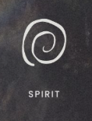
Life (Prana)
Flame (Agni)
Dot (Point of Origin)

Logo:


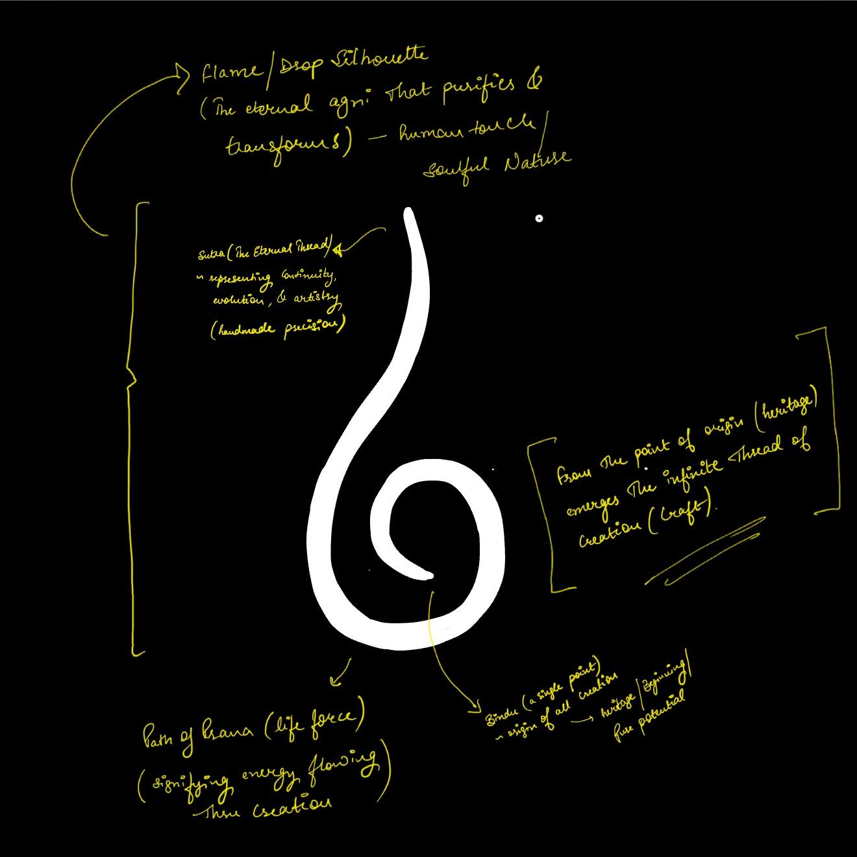
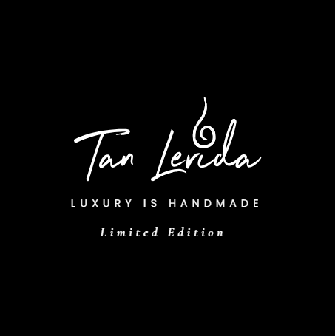

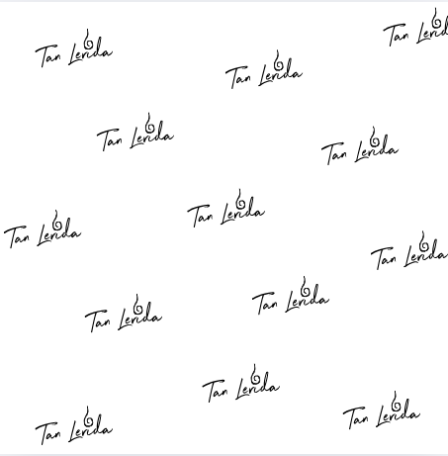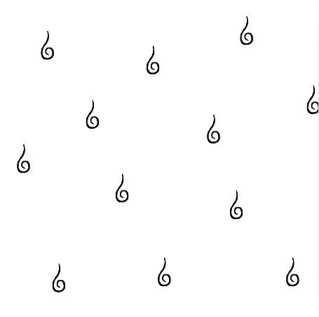

Elements to consider:

